0

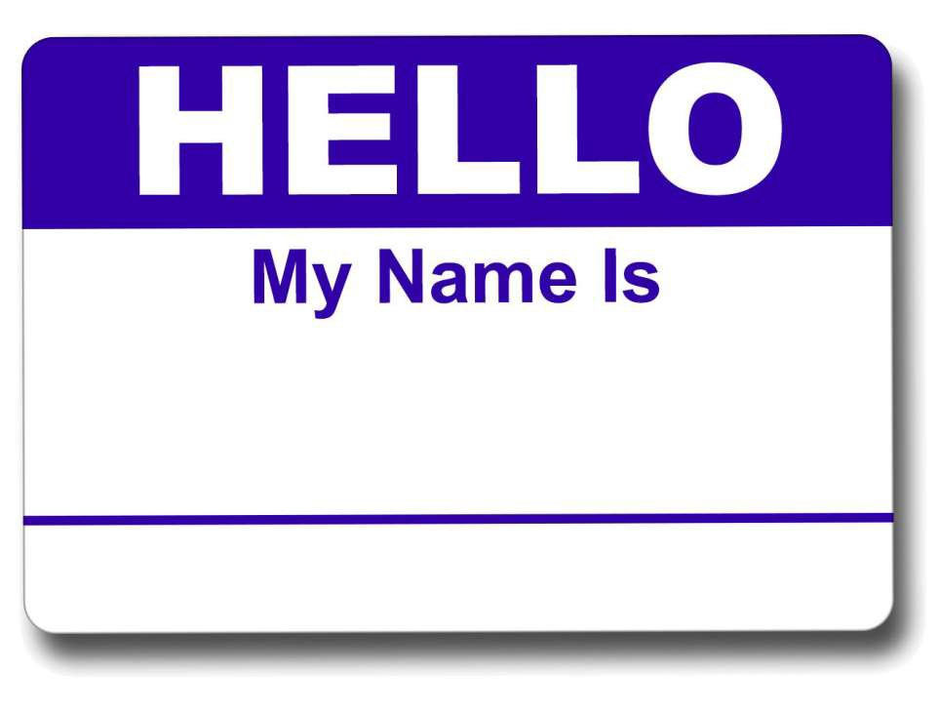Certified Scrum Product Owner

(CSPO)
A WORKBOOK FOR REFERENCE TO HELP YOU BECOME A GREAT PRODUCT OWNER



Mark Palmer
CERTIFIED SCRUM TRAINER & AGILE COACH

SCRUM ALLIANCE CERTIFICATIONS 2
YOUR INSTRUCTOR 3
BOSSES & WORKERS 4
5 LEVELS OF PLANNING 5
PRODUCT VISION 6
GOAL SETTING 7
PERSONAS 8
STORY MAPPING 9
USER STORIES 10
ESTIMATION 11
PRIORITIZATION TECHNIQUES 12
RELEASE PLANNING 17
SIMULATION 21
TEACH BACK 22
AGILE OVERVIEW 23
THE AGILE MANIFESTO 31
12 PRINCIPLES OF AGILITY 34
SCRUM VALUES 35
SCRUM OVERVIEW 36
BUILD YOUR OWN SCRUM 39
SCRUM ROLES 40
SCRUM EVENTS 44
SETTING EXPECTATIONS 46
NOTES 47

1

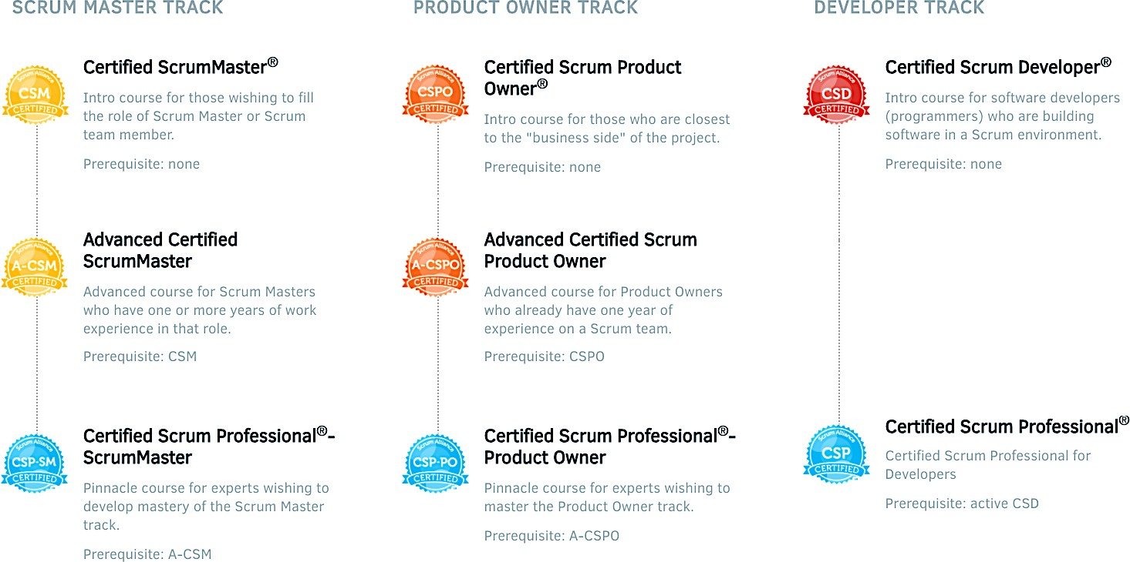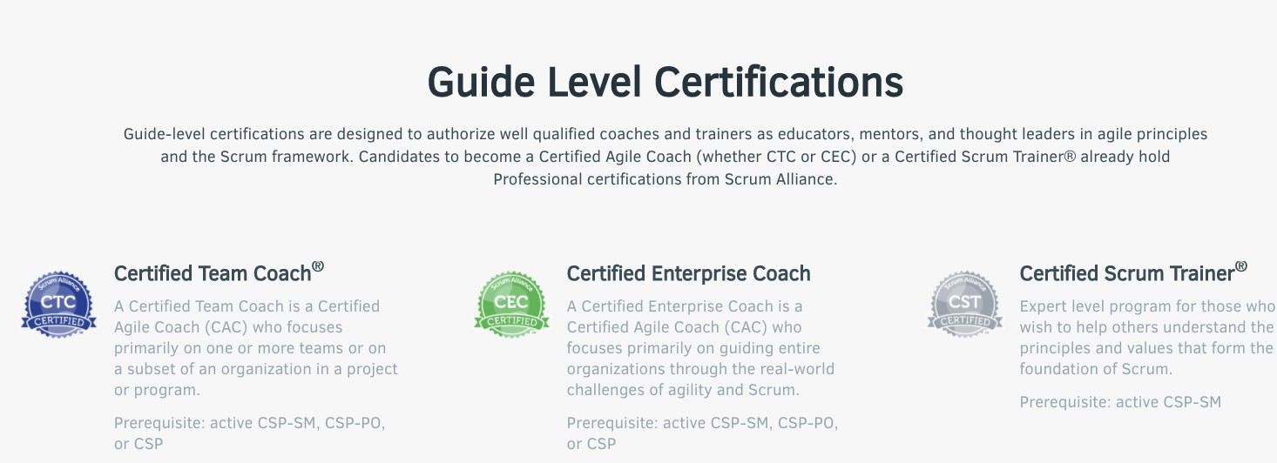

2



  Mark Palmer mark@greatfishagility.com www.greatfishagility.com  www.linkedin.com/in/markcpalmer/ | - 25 years IT experience  - 10 Years as a Developer  - 5 years as a Waterfall Project Manager  - Owned 3 businesses  - 16 years agile experience  - 6 years as a Scrum Master  - 2 years as a Product Owner  - 5 years as an Agile Coach  - 3 years as a Trainer

Scrum Alliance Certifications
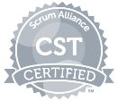

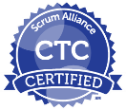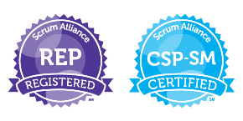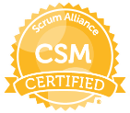


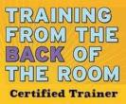Other Agile/Scrum Certifications

3



Self-organization is to Scrum as the heart is to the human body. Without it, Scrum cannot reach its fullest potential.

Bosses & Workers Debrief:
What is one word that describes how you felt in round 1? Why?

What is one word that describes how you felt in round 2? Why?

What is one word that describes how you felt in round 3? Why?

Did you like being micro-managed? Did you like micro-managing?

What did you notice about teams coordinating with each other as the rounds progressed?

What did you notice about the scoreboard data?

Workers – how did it feel to have your boss serve you in round 3?

Bosses – how did it feel to serve your workers in round 3?

4


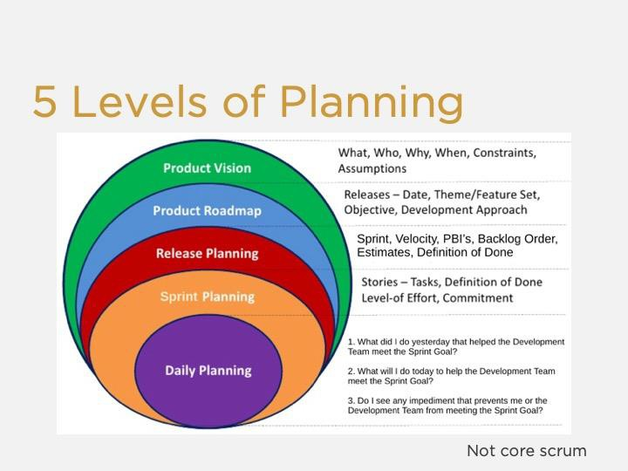
NOTES:

5



Create at least 4 goals for your product. Examples could be:

- Capture market share
- Create a new market
- Increase revenue
- Reduce costs
- Optimize processes

List your goals in priority order below:

Rank | Goal | Weight

7



Create at least 2 personas at your table using the template below

Persona Name:
Personality:
Interests:
Reason(s) to Use Your Product:
Reason(s) to Buy Your Product:
Skills:
Tech Savviness:

Persona Name:
Personality:
Interests:
Reason(s) to Use Your Product:
Reason(s) to Buy Your Product:
Skills:
Tech Savviness:

8



Story Mapping is the action of identifying elements of your product, beginning with general and moving to specific.
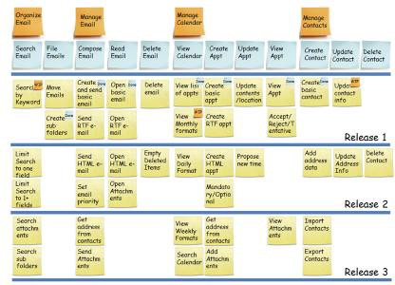

NOTES:
9




What is a User Story?




What are the 3 C’s of a User Story?



Front of Card | Back of Card
As a I want So that | I know this story is done when…  - Acceptance Criteria 1  - Acceptance Criteria 2  - Acceptance Criteria 3

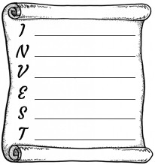
Backlog Refinement

When does it
happen?
How long does it
last?
What’s the
purpose?
Who is in
charge?
PBI Attributes

D O V E

10

Prioritization Techniques

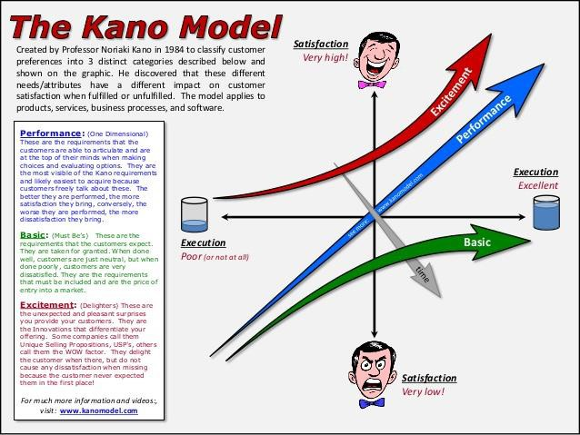
NOTES:
12

Kano Worksheet
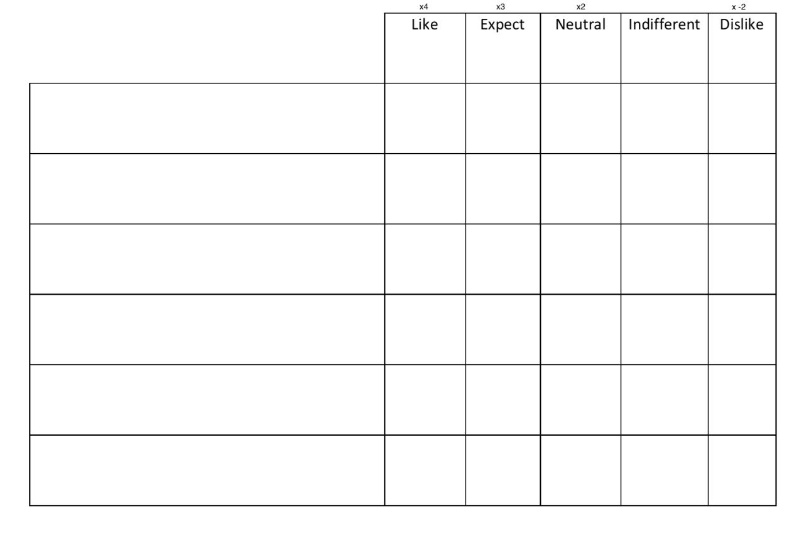
NOTES:

13

Risk/Value

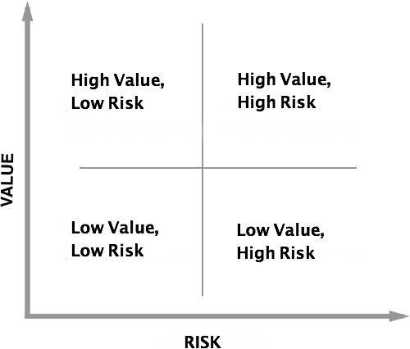
NOTES:

14

MoSCoW
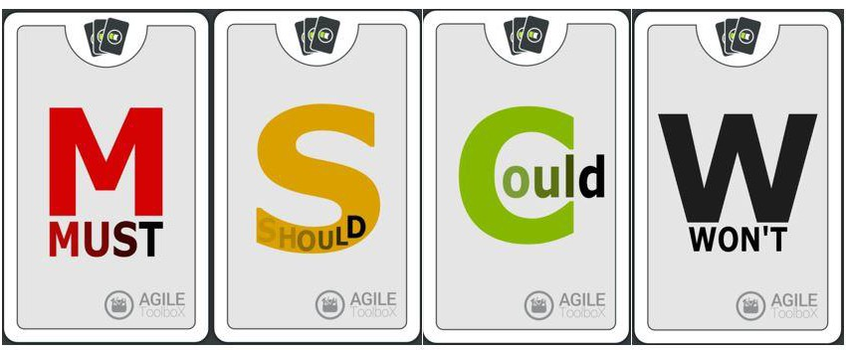

NOTES:

15

ROI
- Reference established product Goals
- Pick any feature of your product
- To which goal(s) does the feature contribute?
  - E.g., feature A contributes to goals 1, 2 and 7.
  - Total value of those 3 goals = 2,300
  - Thus, feature A is worth 2,300 value points
- How much effort to build feature A?
  - Team has sized feature A as being 8 story points (more on story points later)
  - Divide value points by story points to determine value per point
  - Feature A (2300/8) = 287.5 value points per story point

NOTES:
16



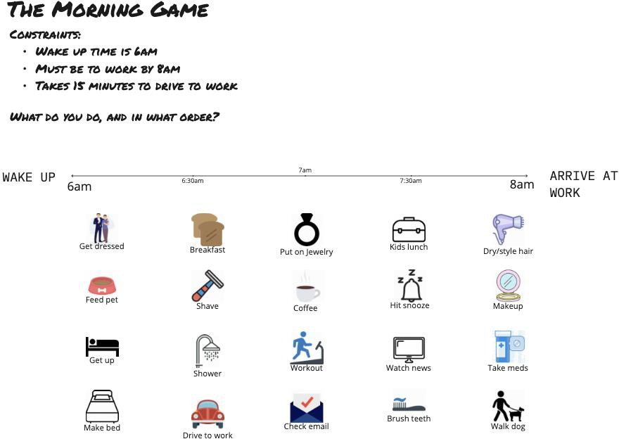
NOTES:
17

Tracking Progress
Assume velocity as per the table below:
Sprint 1: | 10 points
Sprint 2: | 5 points
Sprint 3: | 15 points

Total amount of points in the product backlog = 100
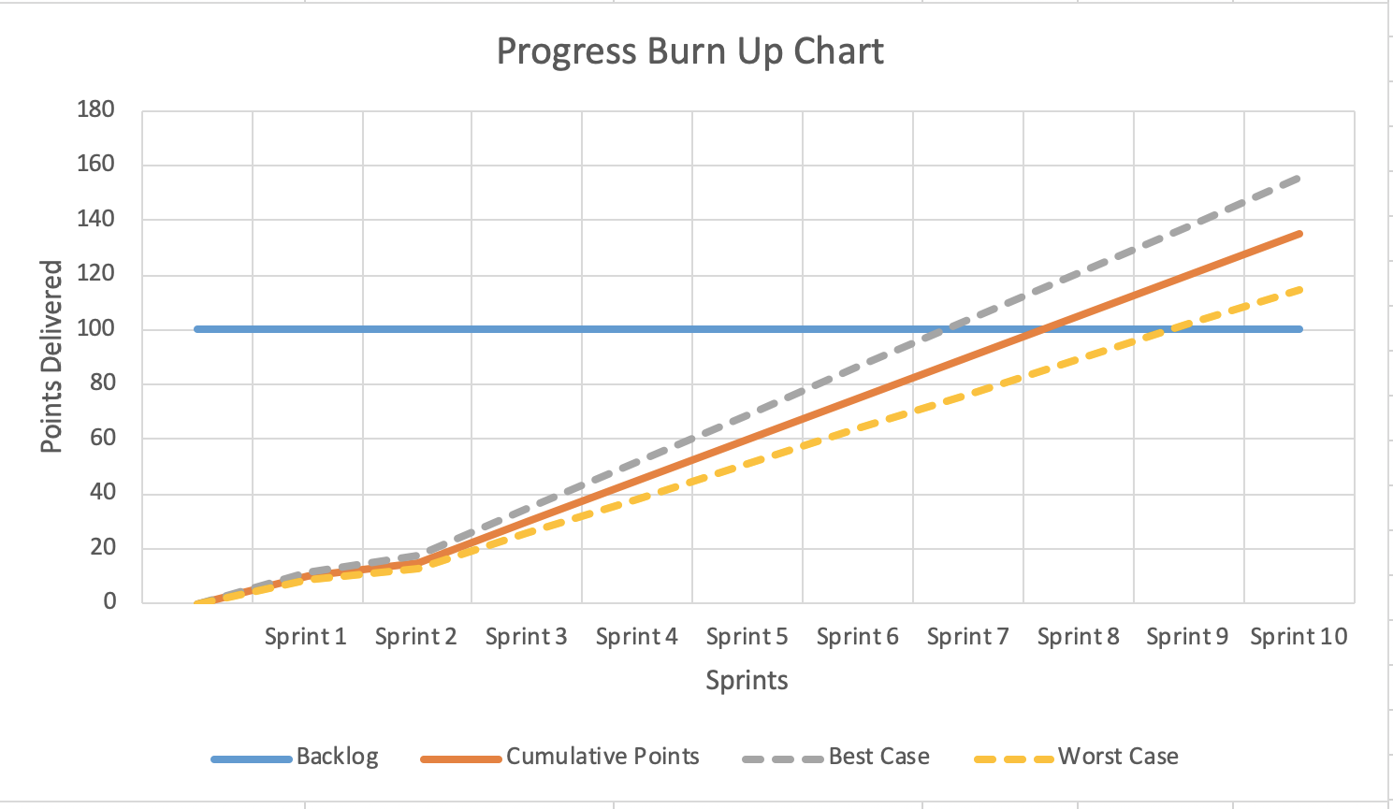

Based on trends, by when will the backlog likely be completed? By when is best case delivery? By when is worst case delivery?

NOTES:
18

Burnup Chart Template

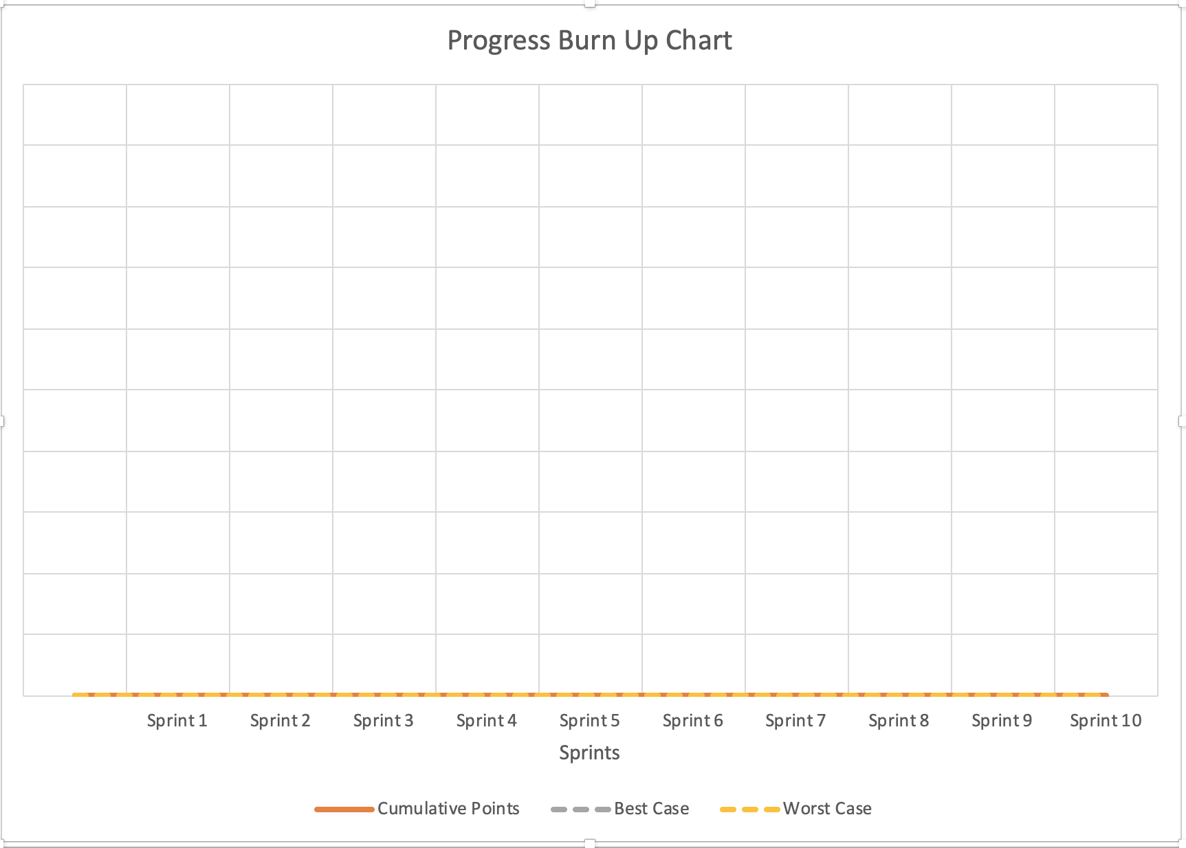

NOTES:
19

NOTES:
20

Simulation
You will have 2 sprints to build the product you created in your product vision. The sprint structure will be as follows:

Sprint Planning (6 minutes)
- Part 1:
- Dev team decides “what” stories to bring into the sprint
- PO clarifies any questions
- PO and dev team together create sprint goal
- Part 2:
1. Dev team figures out “how” to build each story and creates necessary development tasks

Build Your Product (12 minutes)
- Development Team members build the product, Product Owners do not.
- Product Owners have 2 jobs during this timebox:
- Answer any questions the Development Team has about the stories on which they are working.
- Accept or reject completed stories based on acceptance criteria.

Update Your Metrics and Info Radiators (3 minutes)
- Update your Scrum Board; Update your burn-up chart; Update your Sprint Report

Sprint Review (3 minutes)
- Provide available metrics
- Demonstrate the Product Increment to your customer

Backlog Refinement (10 minutes)
- If any changes are needed in your product backlog, this is the time to make them.

Retrospective (3 minutes)
- How can your team improve itself for the next sprint?

What were your takeaways?

21

Teach Back
The best way to learn is to teach. And the best way to help your company succeed with Agile and Scrum adoption is for YOU to educate them. The teach back will give you practice at two key skills:
- Teaching others what you’ve learned
- Conveying the value of doing thing differently than they are used to doing them

Fill out the details about your experience below:
For the Teach Back my
partner was:




22


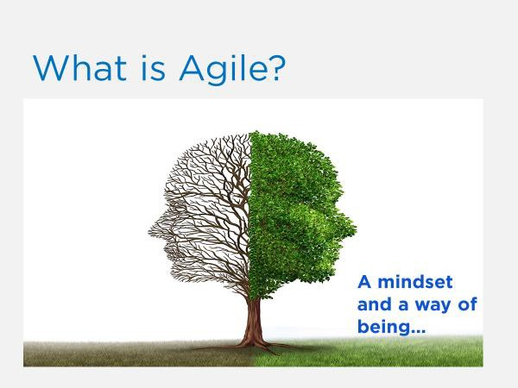
NOTES:
23

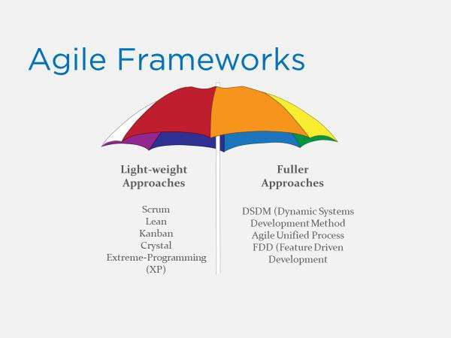
NOTES:
24

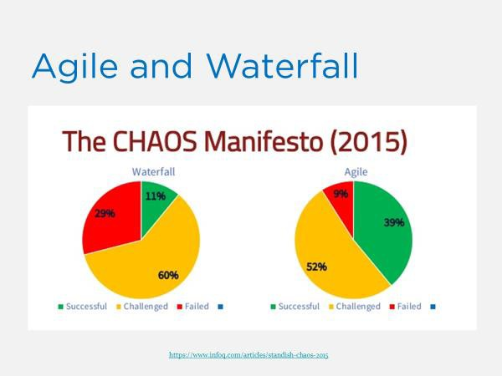
NOTES:
25

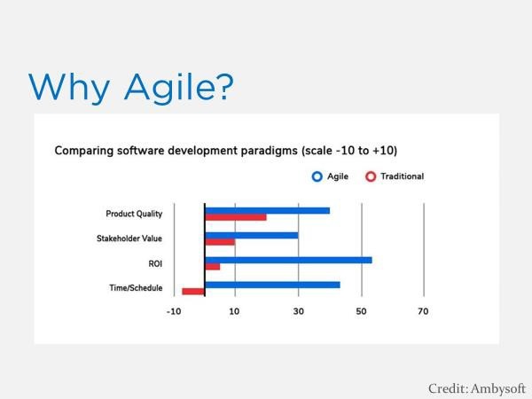
NOTES:
26

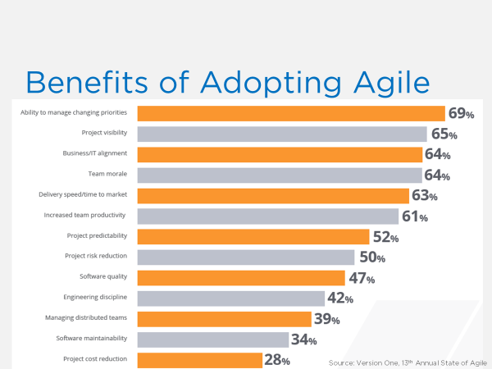
NOTES:
27

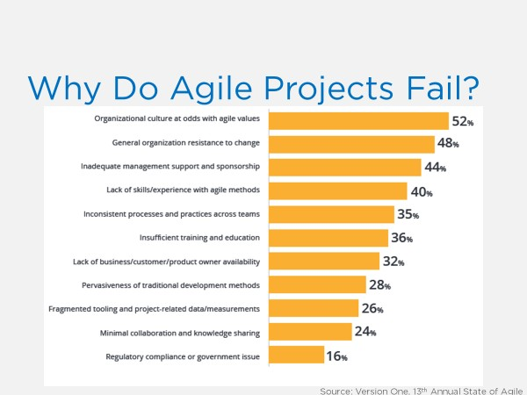

NOTES:
28

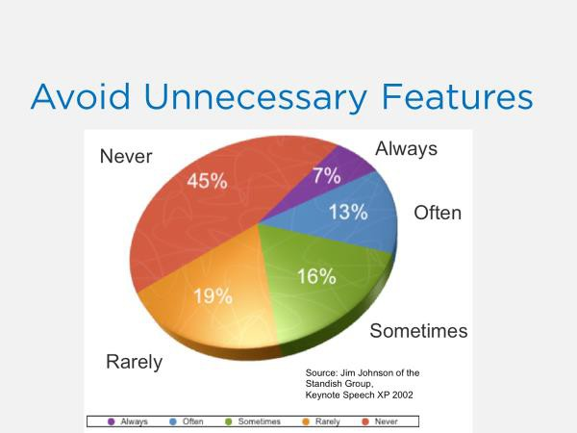
NOTES:
29

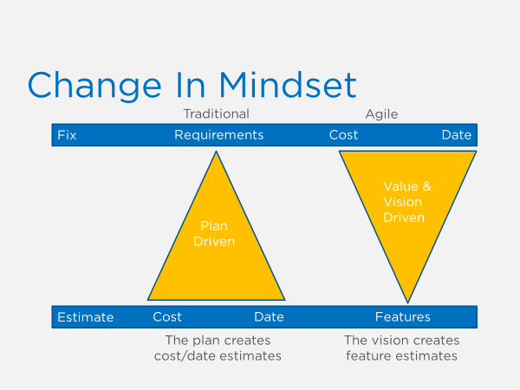

NOTES:
30

The Agile Manifesto
On February 11-13, 2001, at The Lodge at Snowbird ski resort in the Wasatch mountains of Utah, seventeen people met to talk, ski, relax, and try to find common ground—and of course, to eat. What emerged was the Agile ‘Software Development’ Manifesto. Representatives from Extreme Programming, SCRUM, DSDM, Adaptive Software Development, Crystal, Feature- Driven Development, Pragmatic Programming, and others sympathetic to the need for an alternative to documentation driven, heavyweight software development processes convened.

Now, a bigger gathering of organizational anarchists would be hard to find, so what emerged from this meeting was symbolic—a Manifesto for Agile Software Development—signed by all participants. The only concern with the term agile came from Martin Fowler (a Brit for those who don’t know him) who allowed that most Americans didn’t know how to pronounce the word ‘agile’.

Alistair Cockburn’s initial concerns reflected the early thoughts of many participants. "I personally didn't expect that this particular group of agilites to ever agree on anything substantive." But his post-meeting feelings were also shared, "Speaking for myself, I am delighted by the final phrasing [of the Manifesto]. I was surprised that the others appeared equally delighted by the final phrasing. So we did agree on something substantive."

Naming ourselves "The Agile Alliance," this group of independent thinkers about software development, and sometimes competitors to each other, agreed on the Manifesto for Agile Software Development displayed on the title page of this web site.

But while the Manifesto provides some specific ideas, there is a deeper theme that drives many, but not all, to be sure, members of the alliance. At the close of the two-day meeting, Bob Martin joked that he was about to make a "mushy" statement. But while tinged with humor,
few disagreed with Bob’s sentiments—that we all felt privileged to work with a group of people who held a set of compatible values, a set of values based on trust and respect for each other and promoting organizational models based on people, collaboration, and building the types of organizational communities in which we would want to work. At the core, I believe Agile Methodologists are really about "mushy" stuff—about delivering good products to customers by operating in an environment that does more than talk about "people as our most important asset" but actually "acts" as if people were the most important, and lose the word "asset". So in the final analysis, the meteoric rise of interest in—and sometimes tremendous criticism of— Agile Methodologies is about the mushy stuff of values and culture.

For example, I think that ultimately, Extreme Programming has mushroomed in use and interest, not because of pair-programming or refactoring, but because, taken as a whole, the practices define a developer community freed from the baggage of Dilbertesque corporations. Kent Beck tells the story of an early job in which he estimated a programming effort of six
31

weeks for two people. After his manager reassigned the other programmer at the beginning of the project, he completed the project in twelve weeks—and felt terrible about himself! The boss—of course—harangued Kent about how slow he was throughout the second six weeks.
Kent, somewhat despondent because he was such a "failure" as a programmer, finally realized that his original estimate of 6 weeks was extremely accurate—for 2 people—and that his
"failure" was really the manager’s failure , indeed, the failure of the standard "fixed" process
mindset that so frequently plagues our industry.

This type of situation goes on every day—marketing, or management, or external customers, internal customers, and, yes, even developers—don’t want to make hard trade-off decisions, so they impose irrational demands through the imposition of corporate power structures. This
isn’t merely a software development problem, it runs throughout Dilbertesque organizations.

In order to succeed in the new economy, to move aggressively into the era of e-business, e- commerce, and the web, companies have to rid themselves of their Dilbert manifestations of make-work and arcane policies. This freedom from the inanities of corporate life attracts
proponents of Agile Methodologies, and scares the begeebers (you can’t use the word ‘shit’ in a professional paper) out of traditionalists. Quite frankly, the Agile approaches scare corporate bureaucrats— at least those that are happy pushing process for process’ sake versus trying to do the best for the "customer" and deliver something timely and tangible and "as promised"— because they run out of places to hide.

The Agile movement is not anti-methodology, in fact, many of us want to restore credibility to the word methodology. We want to restore a balance. We embrace modeling, but not in order to file some diagram in a dusty corporate repository. We embrace documentation, but not hundreds of pages of never-maintained and rarely-used tomes. We plan, but recognize the limits of planning in a turbulent environment. Those who would brand proponents of XP or SCRUM or any of the other Agile Methodologies as "hackers" are ignorant of both the methodologies and the original definition of the term hacker.

The meeting at Snowbird was incubated at an earlier get together of Extreme Programming proponents, and a few "outsiders," organized by Kent Beck at the Rogue River Lodge in Oregon in the spring of 2000. At the Rogue River meeting attendees voiced support for a variety of "Light" methodologies, but nothing formal occurred. During 2000 a number of articles were written that referenced the category of "Light" or "Lightweight" processes. A number these articles referred to "Light methodologies, such as Extreme Programming, Adaptive Software Development, Crystal, and SCRUM". In conversations, no one really liked the moniker "Light", but it seemed to stick for the time being.

In September 2000, Bob Martin from Object Mentor in Chicago, started the next meeting ball rolling with an email; "I'd like to convene a small (two day) conference in the January to February 2001 timeframe here in Chicago. The purpose of this conference is to get all the

32

lightweight method leaders in one room. All of you are invited; and I'd be interested to know who else I should approach." Bob set up a Wiki site and the discussions raged.

Early on, Alistair Cockburn weighed in with an epistle that identified the general disgruntlement with the word ‘Light’: "I don't mind the methodology being called light in weight, but I'm not sure I want to be referred to as a lightweight attending a lightweight methodologists meeting. It somehow sounds like a bunch of skinny, feebleminded lightweight people trying to remember what day it is."

The fiercest debate was over location! There was serious concern about Chicago in wintertime—cold and nothing fun to do; Snowbird, Utah—cold, but fun things to do, at least for those who ski on their heads like Martin Fowler tried on day one; and Anguilla in the Caribbean—warm and fun, but time consuming to get to. In the end, Snowbird and skiing won out; however, a few people—like Ron Jeffries—want a warmer place next time.

We hope that our work together as the Agile Alliance helps others in our profession to think about software development, methodologies, and organizations, in new– more agile – ways. If so, we’ve accomplished our goals.

Jim Highsmith, for the Agile Alliance

©2001 Jim Highsmith

33

We follow these principles:
- Our highest priority is to satisfy the customer through early and continuous delivery of valuable software.
- Welcome changing requirements, even late in development. Agile processes harness change for the customer's competitive advantage.
- Deliver working software frequently, from a couple of weeks to a couple of months, with a preference to the shorter timescale.
- Business people and developers must work together daily throughout the project.
- Build projects around motivated individuals. Give them the environment and support they need and trust them to get the job done.
- The most efficient and effective method of conveying information to and within a development team is face-to-face conversation.
- Working software is the primary measure of progress.
- Agile processes promote sustainable development. The sponsors, developers, and users should be able to maintain a constant pace indefinitely.
- Continuous attention to technical excellence and good design enhances agility.
- Simplicity--the art of maximizing the amount of work not done--is essential.
- The best architectures, requirements, and designs emerge from self-organizing teams.
- At regular intervals, the team reflects on how to become more effective, then tunes and adjusts its behavior accordingly.

1. 5.
2. 6.

3. 7.

4. 8.
9.

10.

11.

12.

34





•  • 
•  • 
•  • 
•  • 
•  • 


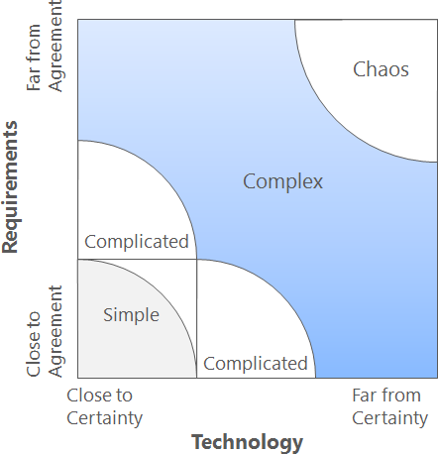

35


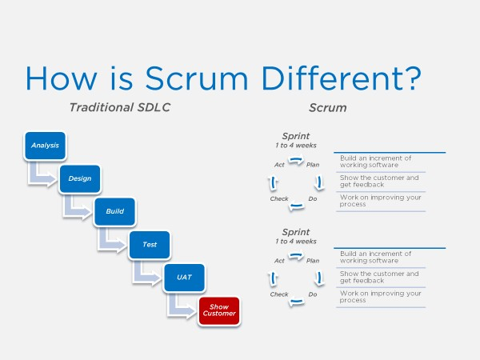
NOTES:
36

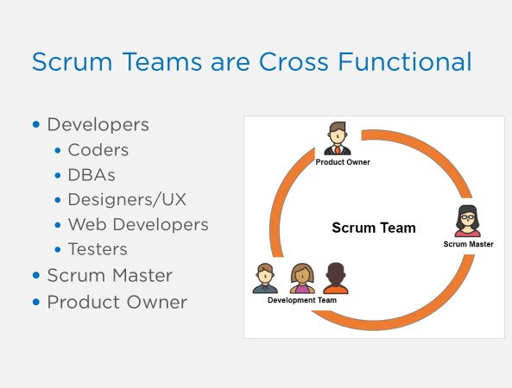
NOTES:
37

Scrum Framework Components

The 3 pillars necessary for Empirical Process Control (and therefore scrum) are:

1.

2.

3.

The 3 roles in scrum are:

1.
2.
3.

The 3 artifacts in scrum are:

1.
2.
3.

The 5 values of scrum are:

1. | 
2. | 
3. | 
4. | 
5. | 
The 5 events (also known as “inspect & adapt points”) are:

1.
2.
3. | 
4.
5.


The 1 activity in scrum is:

1.

A sprint is a - of one
or less.

38

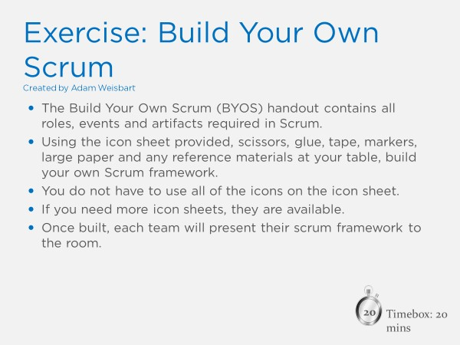
NOTES:
39



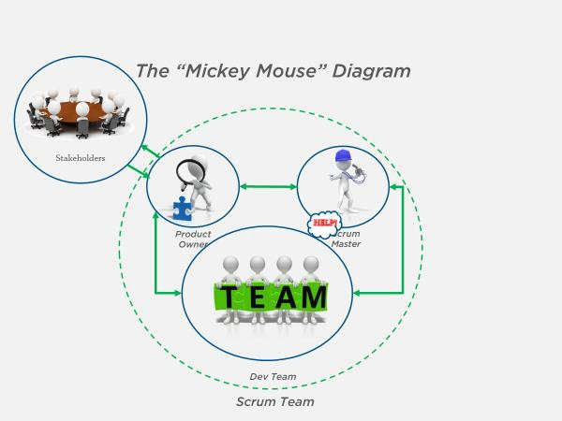

NOTES:

40

The Product Owner

Is | Is Not
Does | Does Not

41


The Scrum Master

Is | Is Not
Does | Does Not

42

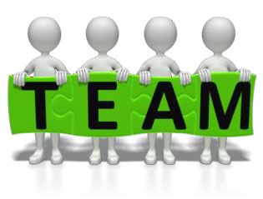
The Development Team
Is | Is Not
Does | Does Not

43










NOTES:


NOTES:

44





NOTES:

NOTES:

45


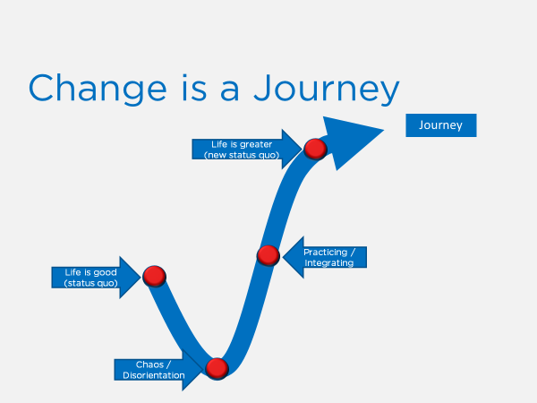

NOTES:
46



47

NOTES:

48

NOTES:

49

